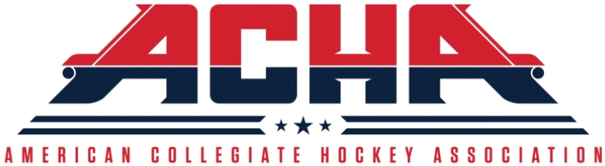
ACHA INCIDENT REPORT FORM
Date of Game:
Rink/Arena:
Division:
Home Team:
Visiting Team:
Submitter Name:
Email Address:
Daytime Phone:
Alt. Phone:
Report must be submitted to appropriate ACHA commissioner(s) within 48 hours of incident. Include ACHA Referee-in-Chief on all email reports.
Based on the report and supporting score sheet and/or video, commissioner will provide a guidance.
Men’s Division 1  Brian Moran  bmoran4@achahockey.org |  | Women’s Division 1  Molly Mahoney  mmahoney@achahockey.org
Men’s Division 2 (email both)  Dave Kurtz (dkurtz@achahockey.org)  Jay Peacock (jpeacock@achahockey.org) |  | Women’s Division 2  Taylor Hadley  thadley@achahockey.org
Men’s Division 3 (email both)  Zack Warson (zwarson@achahockey.org)  Ken Day (sarge@achahockey.org) |  | Referee-in-Chief  Ed Giacomucci  referee@achahockey.org

Please explain the incident in the space below. Please use words “end of report” when complete.

